Wallet Guard

# 

# Team Coding Corona

| Name | Registration Number |
| --- | --- |
| Abarna.U | IT19116952 |
| Parathan.T | IT19125176 |
| Praveena.T | IT19243672 |

# Data Structure

# 

# 

# 

# 

# 

# 

# UML Diagrams

## Use Case Diagram

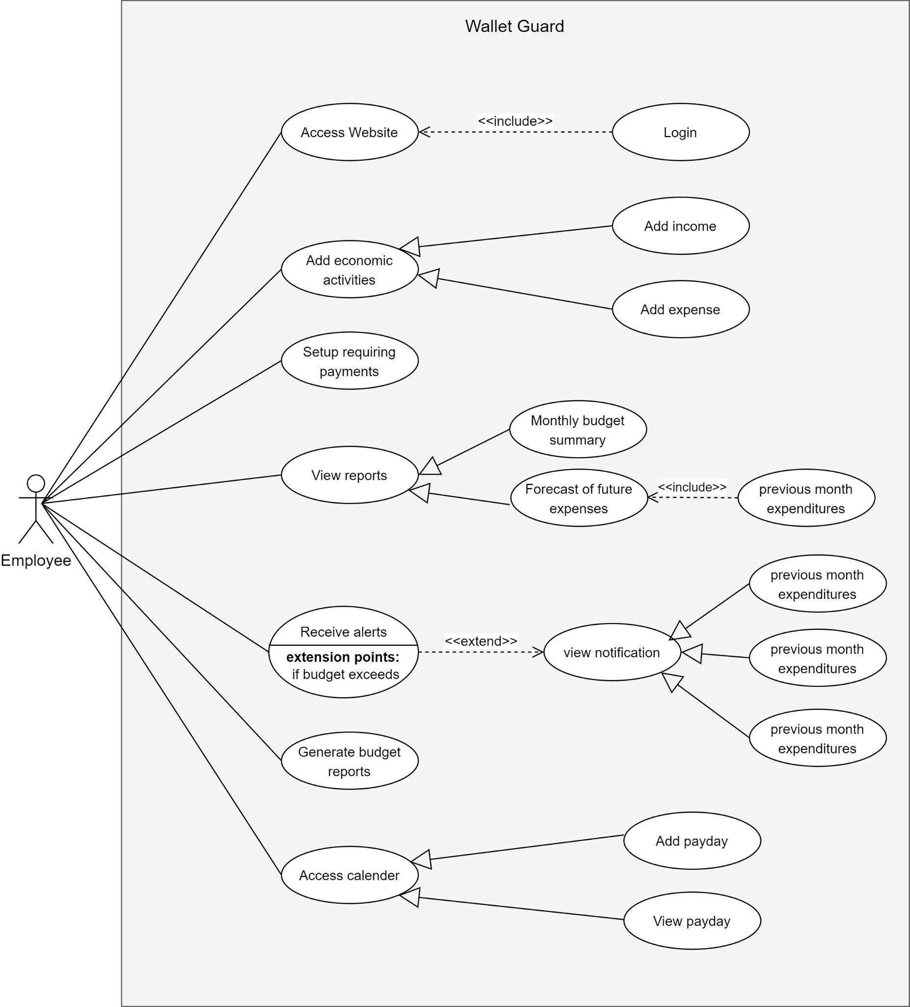

## Class Diagram

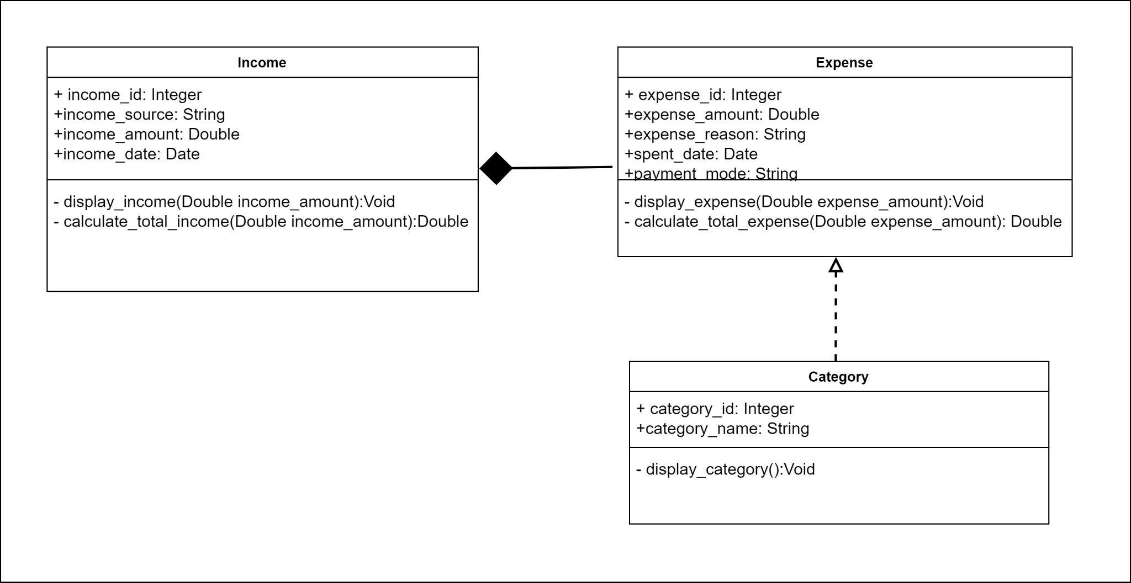

# 

# Non Functional Requirements

1. **High in performance**

The application has a speed of access, less than a second.

1. **Scalable**

The application is capable of handling a large number of user traffic at one time.

1. **Available**

The application is available for the user to access at anytime

1. **Security**

The user is authenticated when accessing the web application to prevent unauthorized access.